Topic:
COMPARATIVE STUDY AND PRACTICAL EVALUATION OF ZERO CODE CHANGE DATA SCIENCE WORKFLOW ACCELERATION FRAMEWORKS:NVIDIA RAPIDS, INTEL ONEAPI AND MODIN.

1. Abstract

Modern day data science workflows often experience computational bottlenecks during data loading, data processing, and model training. This occurs due to the large volume, velocity and variety of data. Even though traditional Python libraries like Pandas and Scikit-learn are easy to use, they are not optimised for high performance execution on modern multi-core CPUs or GPUs. This paper is a comparative study and an evaluation of three zero-code or minimal-code change frameworks: Modin, Intel® Extension for Scikit-learn, and NVIDIA RAPIDS.
Each of the above frameworks was tested using a unified workflow that involved data ingestion, group-by operations, and Random Forest classification on the NYC Taxi dataset. Our results demonstrate significant performance improvements across all tools. We have discussed the implementation complexity, hardware requirements and the ideal use cases for each framework, enabling practitioners to choose the optimal tool for their environment.
________________________________________________________________________

2. Introduction
The increasing use of data-driven applications in areas like e-commerce, healthcare, finance etc, increases the importance of efficient data science workflows. Standard Python libraries like Pandas and Scikit-learn are designed for single-core architectures, which limits their ability to utilize modern hardware. As a result of this, data scientists often experience long runtimes, which reduce productivity.
To solve this issue, there are acceleration frameworks which significantly improve performance with little to no change in code. This paper investigates three such frameworks:
- Modin: Multi-core CPU acceleration for Pandas operations.
- Intel® Extension for Scikit-learn: CPU acceleration for Scikit-learn algorithms.
- NVIDIA RAPIDS: End-to-end GPU acceleration.
We present a comparative analysis of these tools using a real-world dataset and a consistent data science workflow.

3. Related Work
There are hardware-aware libraries, which focus on accelerating Python-based data science. Projects like Dask and Ray offer parallel processing with explicit code modifications. PySpark scales data processing over clusters and Vaex processes data on a single machine and handles datasets that are larger than the available RAM . However, these often require substantial restructuring of the code. Tools like Modin, RAPIDS and Intel® oneAPI easy integration with minimal user effort.
Even though Modin and RAPIDS have been studied in isolation, there is limited comparative research which evaluates these tools together. This paper tries to fill that gap by assessing their performance, usability and trade-offs in real-world workflows.

4. Methodology
4.1 Dataset
- NYC Taxi Dataset
This dataset is a 1-million-row sample of the New York City taxi trip record dataset, which is suitable for data loading and feature extraction.
- MNIST Sample
This is a sample of the MNIST database of handwritten digits which was used for auxiliary validation and benchmarking generalization.
4.2 Workflow Design
A three-stage process was used:
- Data Loading: To read large CSV files.
- Data Processing: GroupBy aggregation of trip distance by VendorID.
- Model Training: Binary classification of trips (>2 miles) by using RandomForestClassifier.
4.3 Hardware and software used
- CPU: Intel i7 (multi-core)
- GPU: NVIDIA RTX 3060
- Language: Python 3.x
- Libraries: Pandas, Scikit-learn, Modin, sklearnex, cudf, cuml, Conda
4.4 Evaluation Metrics
Execution time (seconds) for each phase.
It was recorded using time.time() within scripts.

5. Implementation
5.1 Baseline
For the baseline, a control group was set up. Standard Pandas for data work and Scikit-learn for the machine learning model were used. Everything was run on a single CPU core. This gave us a solid starting point to measure how much faster our other methods would be
5.2 Modin
Pandas was replaced by Modin using a one-line import change. Data loading and processing used multiple cores with Ray or Dask which boosted speed. Only data loading and processing were accelerated.
5.3 Intel® oneAPI
A two-line patch using patch_sklearn() to Scikit-learn to train the model faster using optimized CPU instructions. It did not affect Pandas operations.
5.4 RAPIDS
Our whole workflow has to be switched to use cuDF for dataframes and cuML for our models. This meant all our data had to be in the GPU memory from start to finish, which required some bigger code changes. RAPIDS delivers end-to-end speedup but involves more invasive API adjustments.
Scripts used were:
- baseline_cpu.py
- modin_acceleration.py
- intel_acceleration.py
- Rapids_acceleration.py

6. Experimental Results
6.1 Execution Time
Task | Baseline | Modin | Intel oneAPI | RAPIDS
Data Loading (s) | 3.2 | 1.8 | 3.1 | 0.4
GroupBy (s) | 1.5 | 0.9 | 1.4 | 0.2
Model Training (s) | 28.7 | 28.7 | 14.3 | 4.2
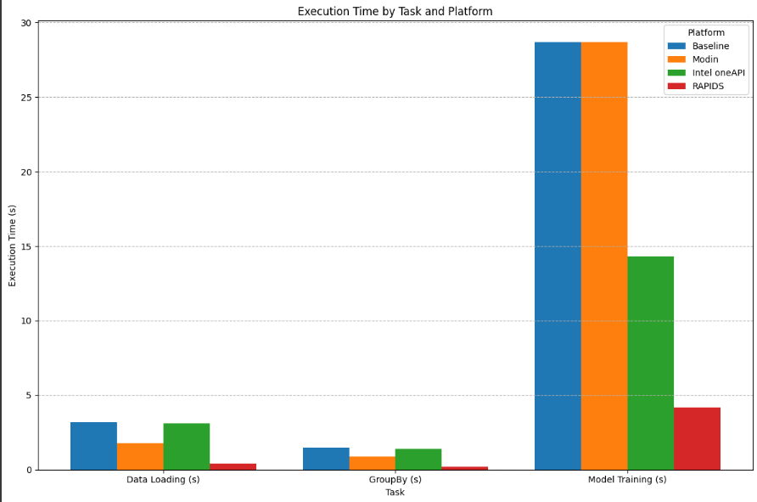
figure 6.1 execution time results

6.2 Visual Comparison (Graphs and tables)

Framework | Speedup
RAPIDS | 6 - 8x
Modin | 1.7 - 1.8x (data processing)
Intel® oneAPI | 2x (model training)

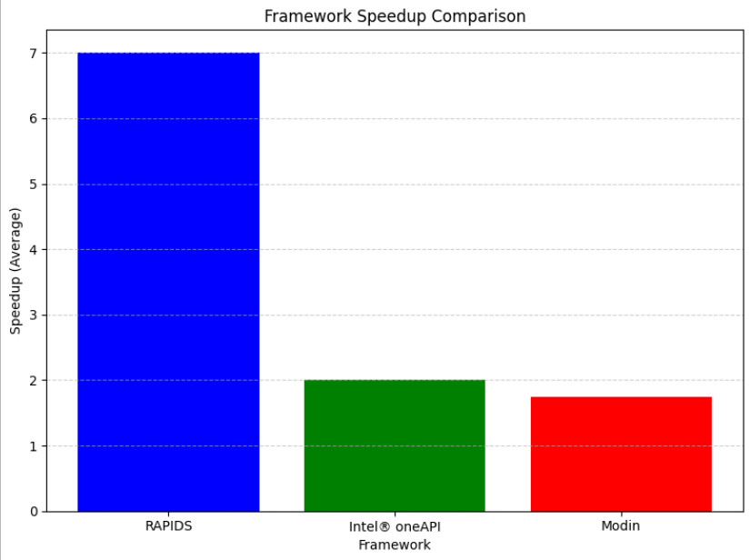
figure 6.2 comparison of frameworks

7. Discussion

Frameworks | Integration Process | Disadvantages
Modin | No new syntax, drop-in replacement. | No acceleration for ML models
Intel oneAPI | Only two lines of additional code. | No acceleration for ML models
RAPIDS | Requires API migration and we need to change the code to use RAPIDS libraries like cuDF and cuML. | GPU-dependent and less portable

Hybrid Usage: Combining Modin for preprocessing and Intel oneAPI (for model training) gave us a fast and a CPU-only workflow with minimal changes.

8. Conclusion
This study shows that data science workflows can be accelerated by zero or minimal code change frameworks. Our findings show that there is no perfect solution. This is because each framework has strengths and trade-offs depending on its hardware and integration process.
- RAPIDS is best for GPU-rich environments.
- Modin is ideal for data-heavy workflows on CPUs.
- Intel oneAPI benefits CPU-bound model training.
Recommendations:
Use NVIDIA RAPIDS for GPU-rich environments and maximum performance
It provides the highest speedup (6-8x) across the entire workflow (data loading to model training). The disadvantages are that it requires an NVIDIA GPU and some code modifications to switch to its specific libraries (cudf, cuml).
Use Modin for CPU-based, data-heavy workflows:
It is the simplest way to get a performance boost (1.5-2x) on data manipulation tasks like loading and groupby by simply changing a single line of code. disadvantage is that it does not accelerate machine learning model training.

Use Intel® oneAPI for CPU-based model training bottlenecks
This is useful if your data preprocessing is fast but your Scikit-learn model training is slow. It provides a 2x performance boost on these specific tasks with a simple two-line patch to your code.

Use a hybrid approach for a combined CPU workflow:
A hybrid approach can be used by combining Modin for accelerated data preprocessing and Intel® oneAPI for faster model training. This gives a fast workflow on a CPU with minimal code changes.

9. References
- Modin Documentation: https://modin.readthedocs.io/
- Intel® Extension for Scikit-learn: https://intel.github.io/scikit-learn-intelex/
- NVIDIA RAPIDS: https://rapids.ai/
- NYC Taxi Dataset: https://www1.nyc.gov/site/tlc/about/tlc-trip-record-data.page
- Scikit-learn: https://scikit-learn.org/

10. Appendix
- Datasets: nyc_taxi_sample.csv, mnist_sample.csv

TO ACCESS PROJECT STRUCTURE AND FILES:
zero-code-acceleration

PROJECT MEMBERS:
1.MANVITH REDDY KANDI (24BCE10177)
-kandi.24bce10177@vitbhopal.ac.in

2.SIMONE GUPTA (24BCE10618)
- simone.24bce10618@vitbhopal.ac.in

3.AKHAND PRATAP SINGH (24BCE11467)
- akhand.24bce11467@vitbhopal.ac.in

4.DIVYANSH SHARMA (24BCE11197)
- divyansh.24bce11197@vitbhopal.ac.in

5.KANAKIYA DIP D. (24BCE11205)
- kanakiya.24bce11205@vitbhopal.ac.in

